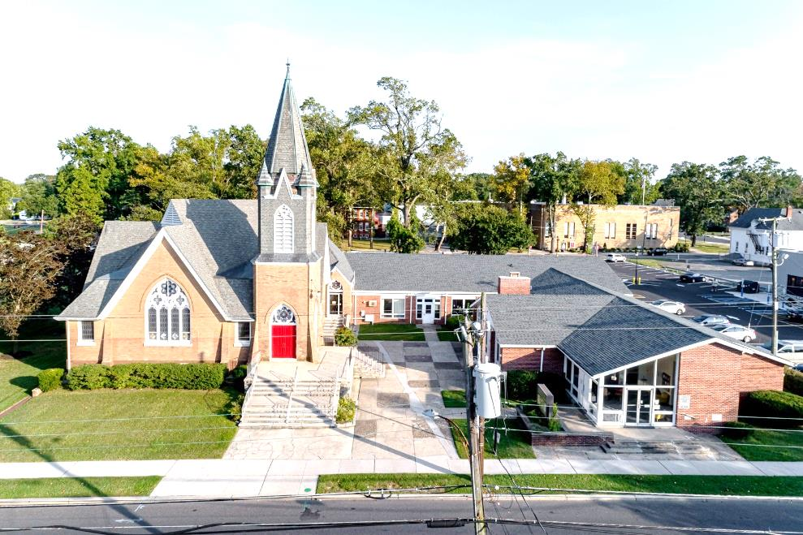

The Presbyterian Church at Hammonton
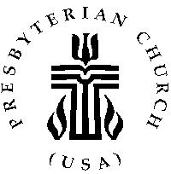

Our vision is to open our doors to all seeking a spiritual home of worship and to carry the light and love of Jesus Christ, our Savior, throughout the community.

MISSION STATEMENT
We are committed to Jesus Christ and the growing of his Church by glorifying God and by proclaiming the good news of the gospel through word and deed. We involve and reach out to our members and our community in Christ’s name through worship, Christian Education, and stewardship to support the mission of our church.

Note: Special thanks to Rev. Dr. Patty Epprecht for leading us in worship today.

Organist: Cindy Birnbaum
Sunday School Superintendent: Beth Burkett-Rice

2022 2023 2024
ELDERS
Eric Copenhaver Robert Bauers Sallye Hershman
Marylee Kondrach Dorrine Esposito Paul Moul
Charles Muller Richard Walker Johanna Johnson

DEACONS
Elsie Bakley Wendy Copenhaver Hilda Lugo
Nancy Foster Ann DiMeo Carol Orsi
Margaret Jones Rebecca Lindstrom Rebecca Villani

Clerk of Session: Beth Burkett-Rice

Church Office: 326 Bellevue Avenue, Hammonton, NJ
Office hours: Tuesday - Thursday 9:30 AM to 12:30 PM
Phone (609) 561-0168 ~ Fax (609) 561-6105
e-mail: office@hammontonpres.org
website: www.hammontonpres.org

THE CELEBRATION OF WORSHIP
JULY 31st, 2022
8th SUNDAY AFTER PENTECOST
VIRTUAL & LIVE SERVICE
11:00am
****************************************************
~ GATHERING IN GOD’S NAME ~
“Welcome to the Presbyterian Church at Hammonton, we are glad you are able to join us. As we gather for worship feel free to pray and meditate on God’s calling in your life. Be respectful of others around you who might be doing the same, prior and during the Prelude, keeping your voice and conversation soft and to a minimum.”

“In the never-ending battle between order and chaos, clutter sides with chaos every time. Anything that you possess that does not add to your life or your happiness eventually becomes a burden.”
- John Robbins

PRELUDE ~“Fairest Lord Jesus”– L. Larson
“Simple Gifts”– G. Sewell
“The Church’s One Foundation”– E. Broughton

~ TIME FOR CENTERING STILLNESS AND SILENCE ~

WELCOME AND ANNOUNCEMENTS

THE PEACE
Let the people greet one another by staying in their seats and saying: “Peace be with you!”

~ HUMBLY APPROACHING GOD ~

OPENING PRAYER Prayer of Anselm
Teach me to seek you,
And as I seek you, show yourself to me,
For I cannot seek you unless you show me how,
And I will never find you unless you show yourself to me.
Let me seek you by desiring you, and desire you by seeking you;
Let me find you by loving you, and love you in finding you.
Amen

CALL TO WORSHIP
One: Praise the LORD! What a great feeling to come before God and sing our praises!
All: God is so good to us, kind and forgiving, loving and gracious. It is right that we bring God our praise!
One: The Lord builds us up and makes us strong. God gathers in all the things that separate from one another and makes us one.
All: How good it is to sing praises to our God; for he is gracious, and a song of praise fits God's worthiness.
One: Great is our God, abounding in might, yet more understanding of us than we can imagine.
All: Come and join our voices so that we can sing to the Lord. With great thanksgiving, with song and words, acts of praise and hearts of joy, let us praise our God.

*HYMN #2271 ~ “Come! Come! Everybody Worship”

CALL TO CONFESSION

PRAYER OF CONFESSION (unison)
God our Creator, we come to you a rebellious people. We have denied your intentions for us; we have sought our own ways rather than the way of Christ. We have refused to learn lessons of the past, and still we remain bound up with past offenses. We dream of what cannot be and yet do not devote ourselves to laying a foundation for genuine hope. Forgive what we have been, amend what we are, and direct what we shall be in order to rise with Christ and serve you with trust and joy.
(silent confession)
ASSURANCE OF FORGIVENESS

*GLORIA PATRI

CHILDREN’S MESSAGE

~ RECEIVING GOD’S WORD ~

PRAYER OF ILLUMINATION

SCRIPTURE READINGS Colossians 3:1-11 (NT, 189)
Luke 12:13-21 (NT, 70-71)

MESSAGE ~ “The Big Garage Sale”
-The Rev. Dr. Patricia Epprecht

Text: And he said to them, "Take care! Be on your guard against all kinds of greed; for one's life does not consist in the abundance of possessions." Luke 12:15

~ RESPONDING TO THE WORD ~

HYMN #2172~ “We Are Called”

*SAYING WHAT WE BELIEVE- Apostle’s Creed

JOYS AND CONCERNS OF THE CHURCH

PASTORAL PRAYER & LORD’S PRAYER
Our Father, who art in heaven, hallowed be Thy name. Thy kingdom come, thy will be done, on earth as it is in heaven. Give us this day our daily bread; and forgive our debts as we forgive our debtors; and lead us not into temptation, but deliver us from evil. For Thine is the kingdom and the power and the glory, forever. Amen.

THE OFFERING OF OUR GIFTS AND OURSELVES

OFFERTORY ~ “Bring Your Thanks to God” -P. Taylor

*DOXOLOGY (#592)
Praise God, from whom all blessings flow; Praise Him, all creatures here below; Praise Him above, ye heavenly host; Praise Father, Son, and Holy Ghost. Amen.

OFFERTORY PRAYER

~ GOING IN GOD’S NAME ~

*HYMN #2149~ “Living for Jesus”

*THE CHARGE AND BENEDICTION

POSTLUDE~ “I’m Gonna Live So God Can Use Me” -G. Sewell

OUR WORSHIP HAS ENDED, LET OUR SERVICE BEGIN

*Signifies stand if comfortable.

Last Week’s Attendance & Offering:
Attendance: 19 people
Offering: $1,123.00
______________________________________________

CHURCH EVENTS
>>>THIS WEEK:
Monday-08/01:
9:00 AM Clothing Closet
-12:00 PM
7:30 PM ESL classes

Tuesday-08/02:
9:00 AM Clothing Closet
-12:00 PM

Wednesday-08/03:
9:00 AM Clothing Closet
-12:00 PM
7:30 PM ESL classes
______________________________________________

>>UPCOMING:
Monday-08/08:
9:00 AM Clothing Closet
-12:00 PM
7:30 PM ESL classes

Tuesday-08/09:
9:00 AM Clothing Closet
-12:00 PM

Wednesday-08/10:
9:00 AM Clothing Closet
-12:00 PM
7:30 PM ESL classes

______________________________________________
BIRTHDAYS:

August 2 Nico Lugo (child)

______________________________________________
ANNIVERSARIES:

No anniversaries this week.

SERVING YOU TODAY:

Liturgist: Rebecca Lindstrom

Ushers: Charles Muller, Captain
Ed Helm
Jennifer Clarke-Helm
Bill Parkhurst

